**server.test.js**

- should create PDF from provided content

- should create PDF from provided content and uploaded file

- should return failure when content is missing

- should handle empty file upload gracefully

- should return failure on server error

**script.test.js**

- should display success message on successful PDF creation

- should display failure message on PDF creation failure

- should handle file upload and display success message

- should display failure message when content is missing

- should display failure message on server error

**api_response.test.js (in development)**

- should initialize instance with default property value (retrieving api key)

- should return processed value from method1

- should return default output for empty input in method2

- should throw error for null input in method3

- should update property value correctly

**flashcard_maker.test.js (in development**

- should handle using api to generate different flash cards

- should return processed value from method1_cards

- should return special output for special case input in method2

- should throw error for undefined input in method3

- should update property value correctly

**useraccount_database.test.js (implementation pending)**

- should initialize instance with start property value

- should return processed value from method1

- should return edge output for edge input in method2

- should throw error for bad input in method3

- should update property value correctly

**All tests passing:**

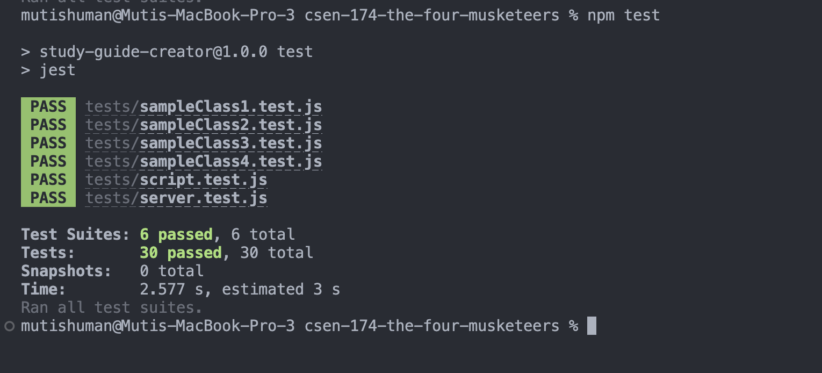

Example of a failing test:

